**ASSIGNMENT 1**

1. In your home directory, create sets of empty practice files

* Create 6 files with names of the form songsX.mp3.
* Create 6 files with names of the form snapX.jpg.
* Create 6 files with names of the form filmX.avi.

In each set, replace X with the numbers 1 through 6.

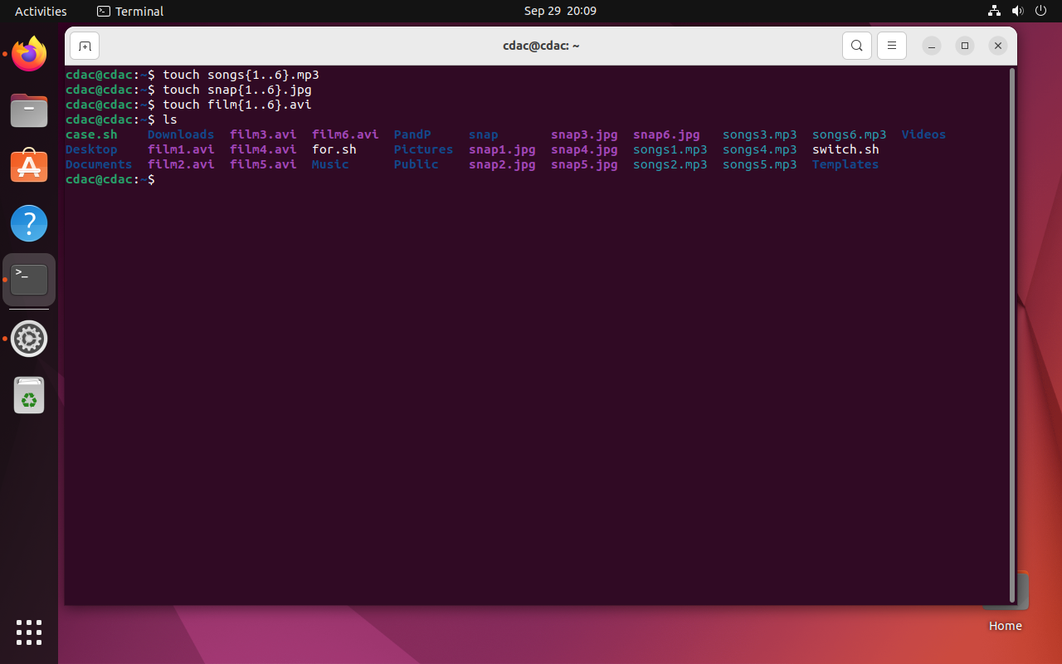

2. From your home directory,

* Move songs file into your Music subdirectory.
* Move snap file into your Pictures subdirectory.
* Move your movie files into Videos subdirectory

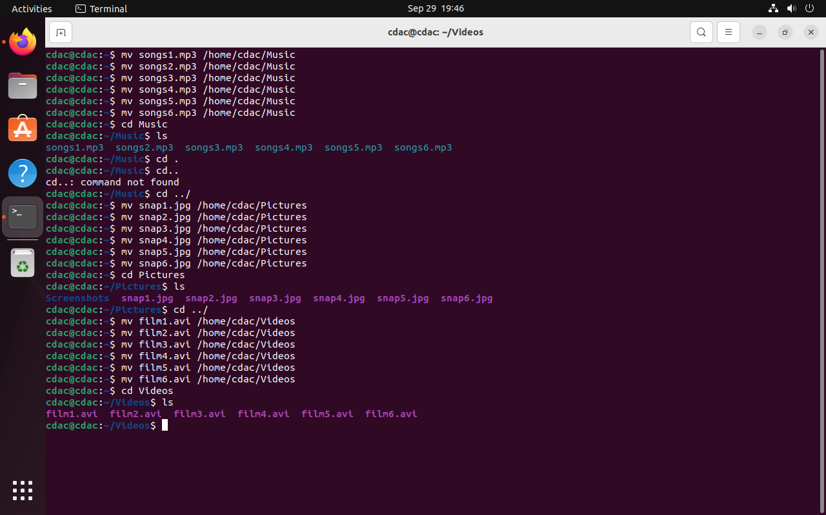

3. Create 3 subdirectories for organizing your files named friends,family,work

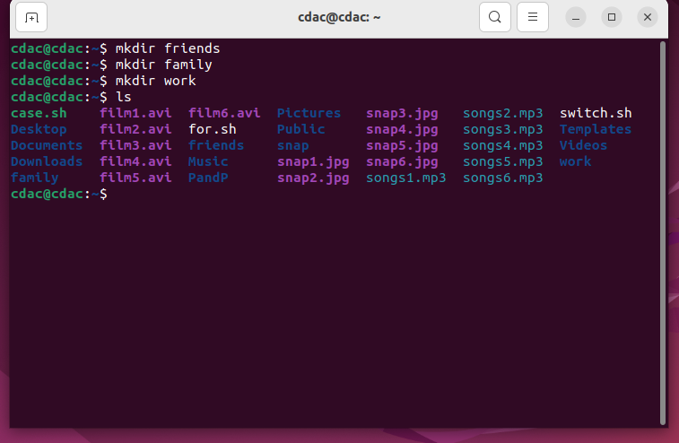

4. Copy files (all types ) containing numbers 1 and 2 to the friends folder.

    Copy files (all types) containing numbers 3 and 4 to the family folder.

    Copy files (all types) containing numbers 5 and 6 to the work folder.

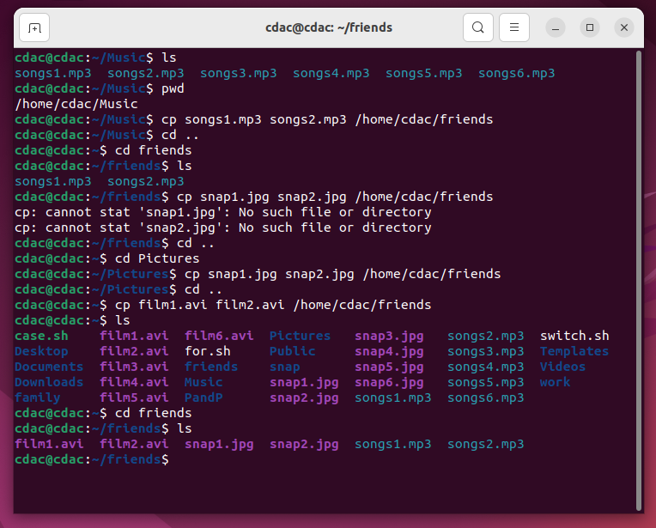

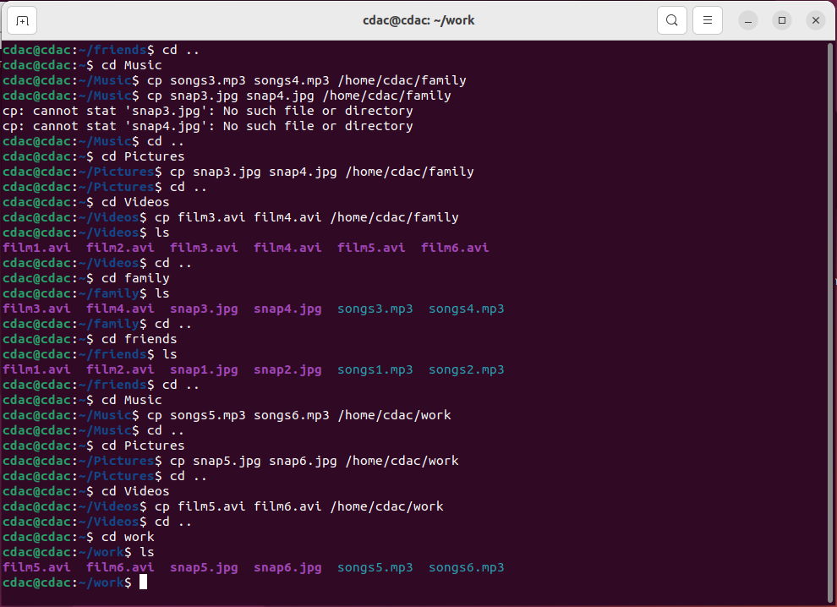

**Assignment no 2**

6. Delete all files in family subdirectory.

7. Delete friends subdirectory

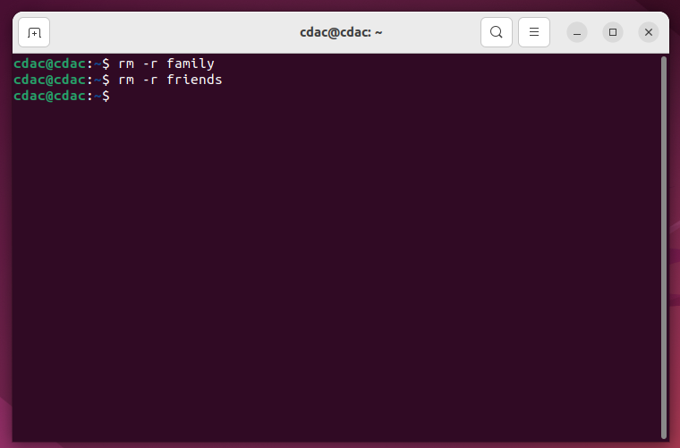

8. Create user tom , bob , sam , prince

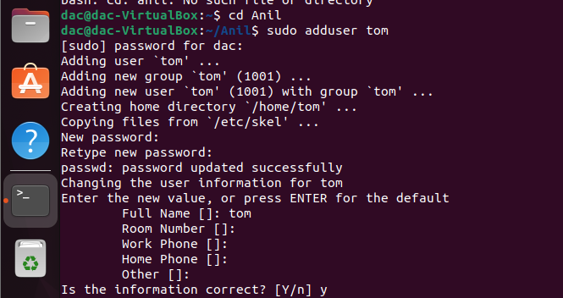

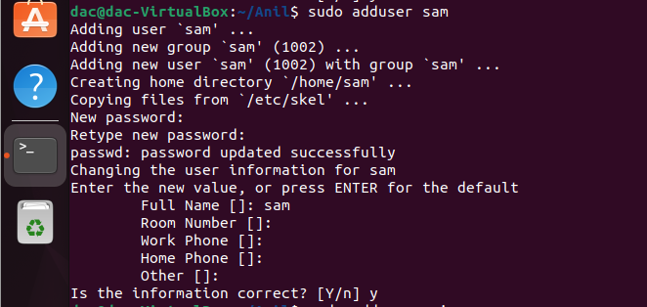

9. Create Group dac , dbda ,ditiss

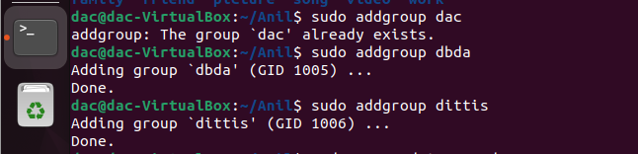

10. add user

Tom in dac

Bob in dbda

Sam in ditiss

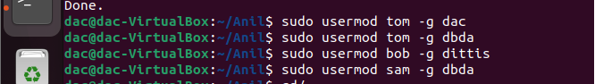

11. login as prince and create iacsd directory in /tmp and create 4 files in iacsd with name project-1 project-2 upto 4

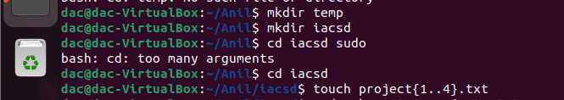

12. assign permissions to project files as below

Project-1 – tom should be owner of this

Project-2 – dac should be owner of this

Project-3 --- others should not have any permission but tom should have rw access

Project-4 – dbda group should have rwx permissions.

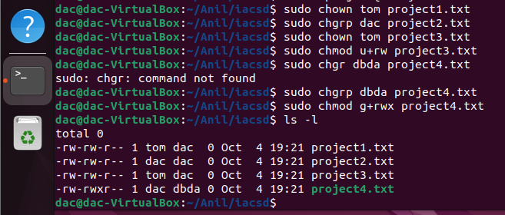

OS Assignment no -3

one

apple

banana

cat

dog

elephant

two

fish

gun

horse

icecream

three

jelly

kitkat

lolipop

marshmallow

four

new

oppo

vivo

china

/home -> mkdir EVERYONE

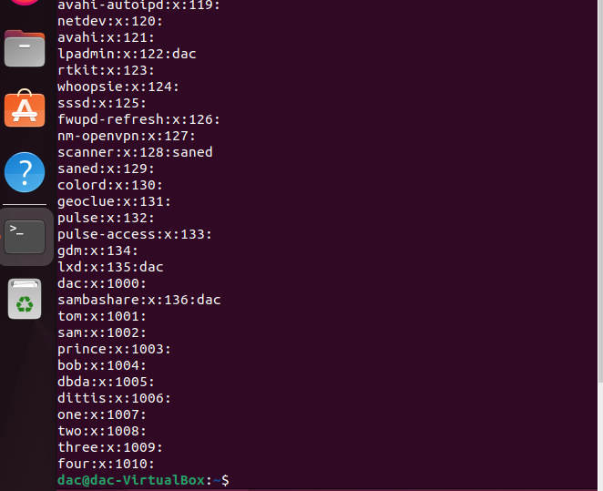

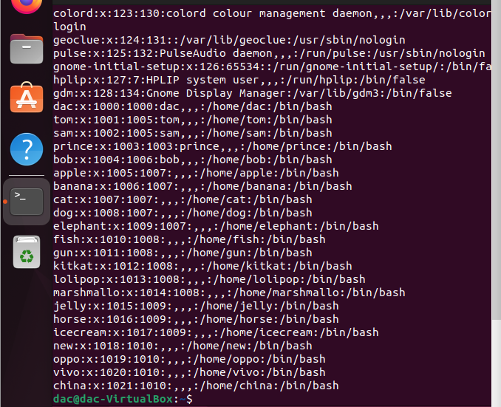

Create a file with every user (whoami >> username.txt)

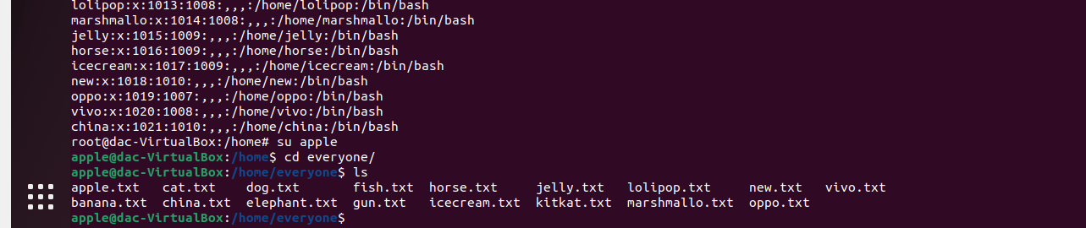

oppo -> primary group change -> one

vivo -> primary group change -> two

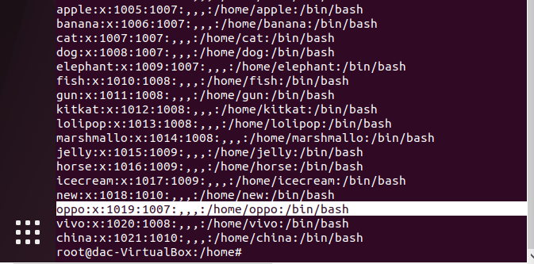

jelly,kitkat, lolipop, marshmallow -> add these users to sudo group

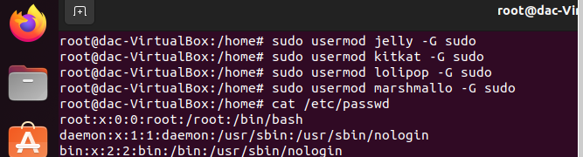

fish,gun -> add these users to one group as well (secondary group)

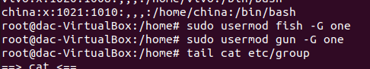

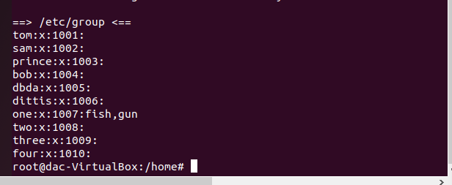

Assignment 4

Q1. Write a shell script tp print

* your are logged in as which user
* in which directory you are
* and in which terminal you are working
* total number of files and directories in current directory

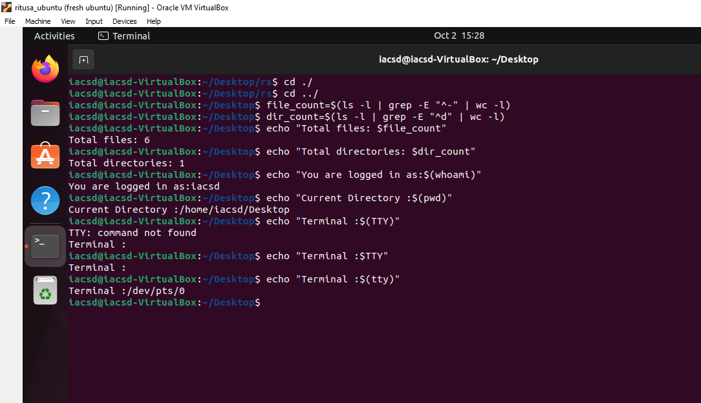

2).Write a shell script to create a menu driven program for adding, deletion or finding a record in a database. Database should have the field like rollno, name, semester and marks of three subjects. Last option of the menu should be to exit the menu.

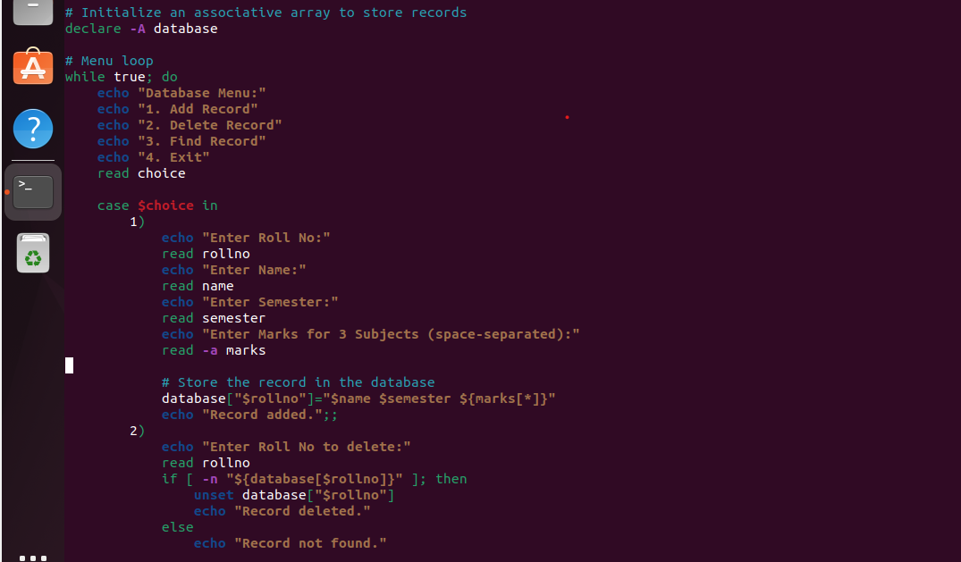

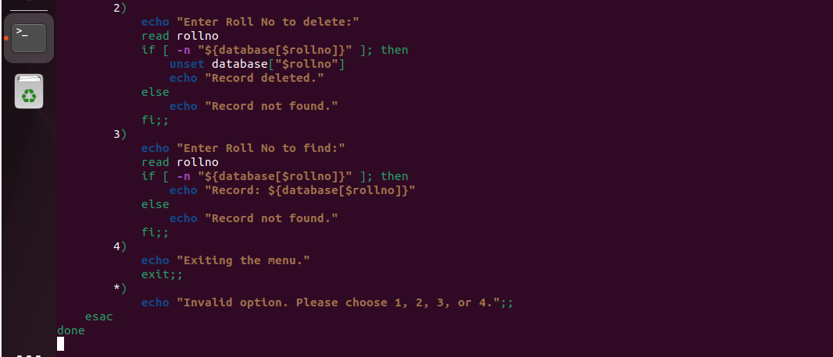

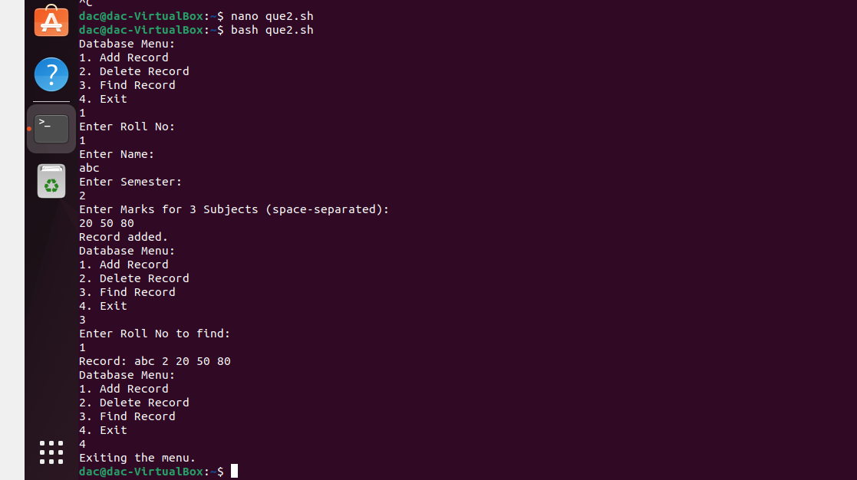

3) Write a Linux shell script to accept 10 number and tell how many are +tive, -tive and zero.

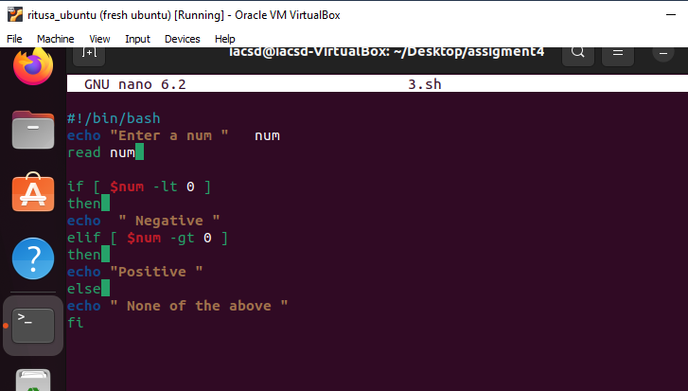

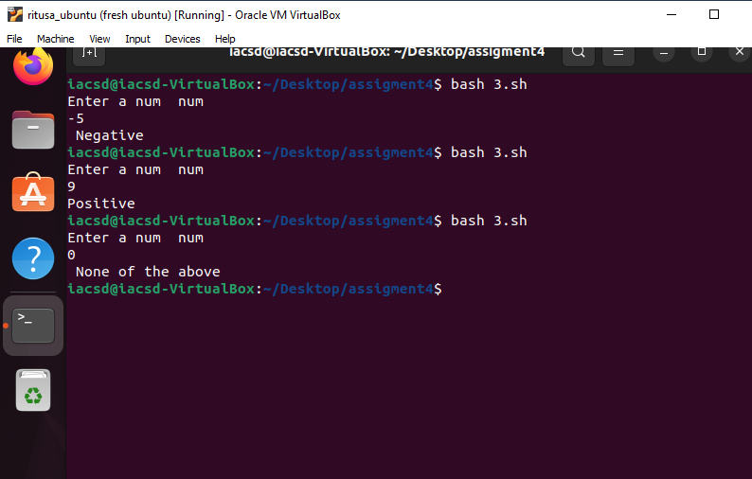

4) Write a shell script to accept five number and display max and min value.

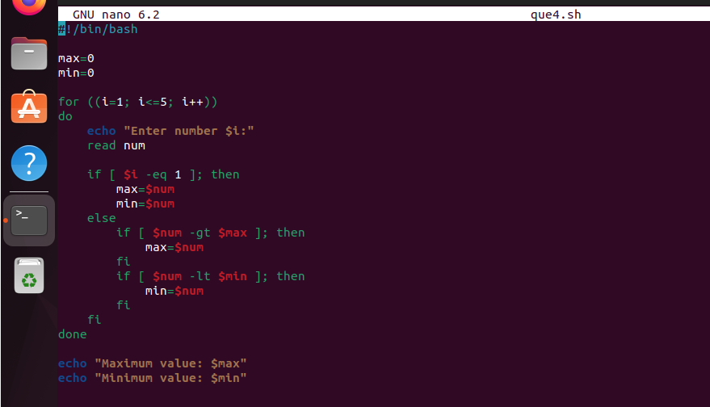

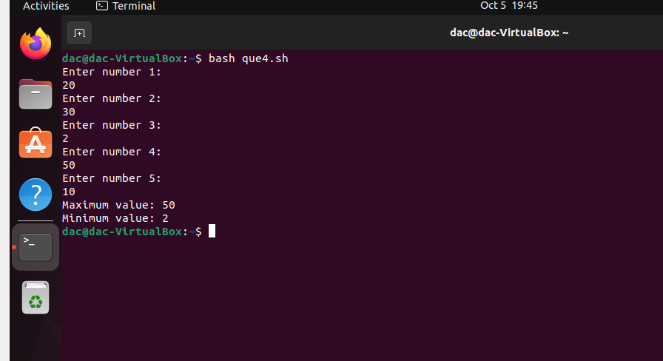

5) Write a script to find out String is palindrome or not.

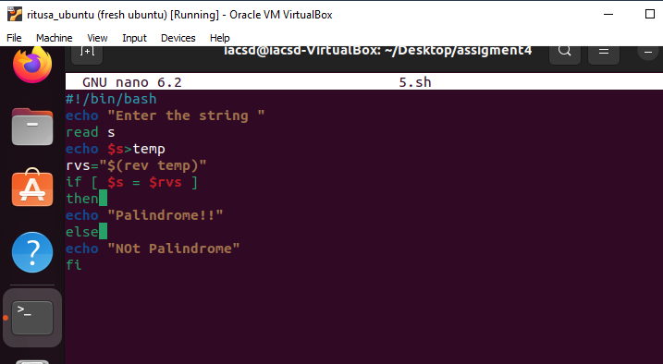

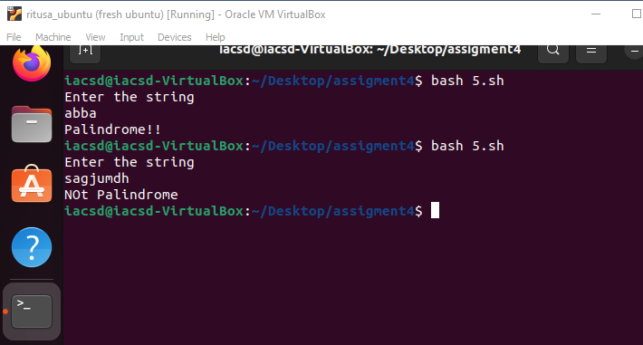

6) Write a shell script to print given number’s sum of all digits (eg. If number is 123, then it’s sum of all digits will be 1+2+3=6

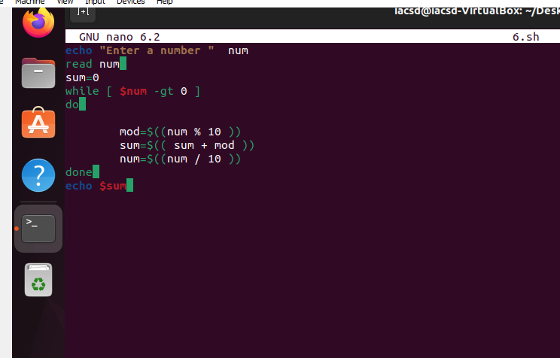

7) Create a script to

Create user , Delete user , Create group , delete Group using case

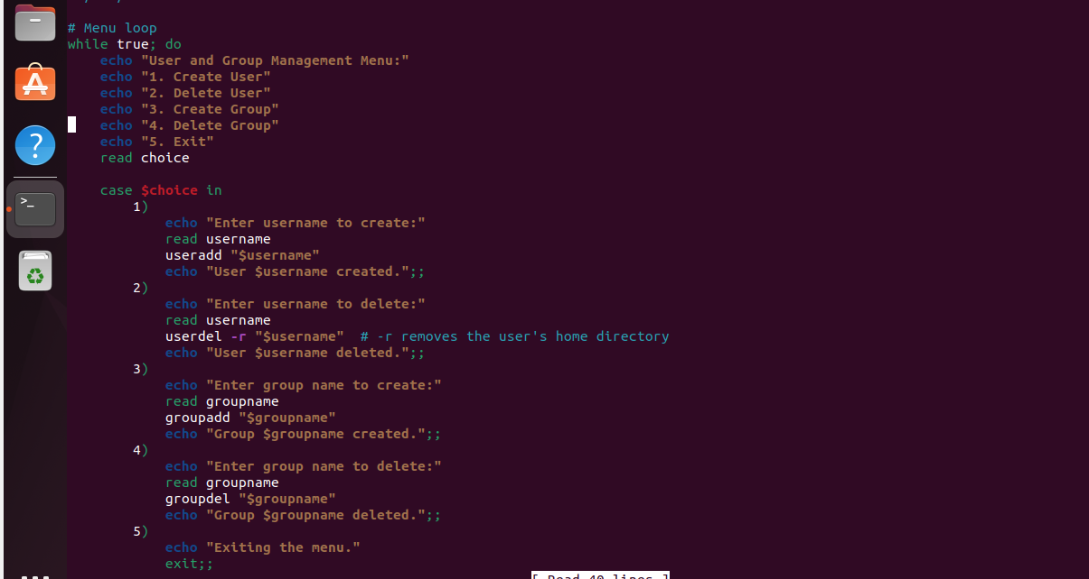

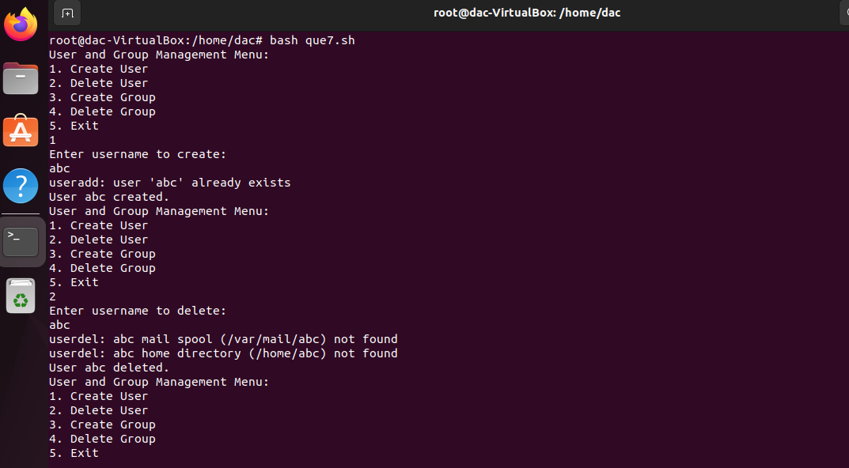

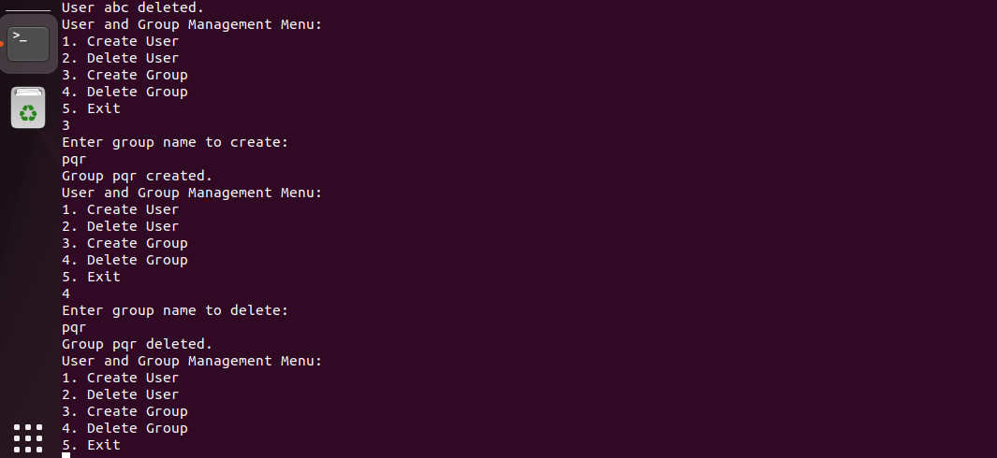

**Assignment no 5**

1. Write a Shell Script to find maximum between two numbers.

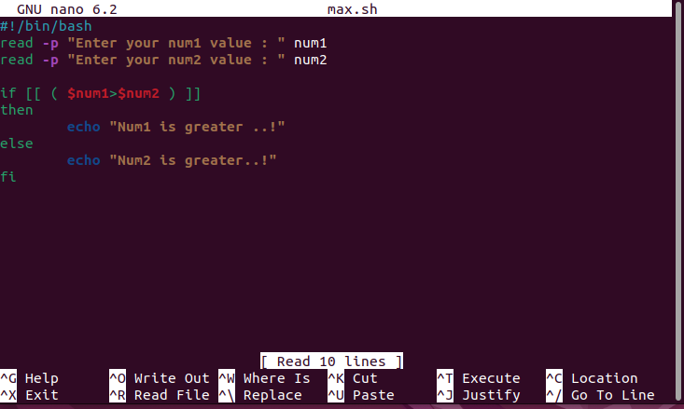

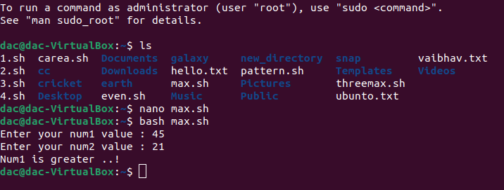

1. Write a Shell Script to find maximum between three numbers.

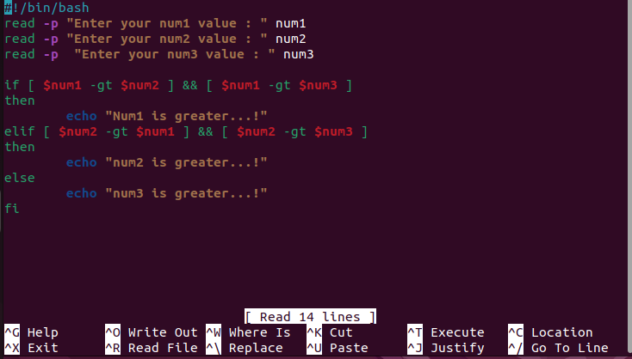

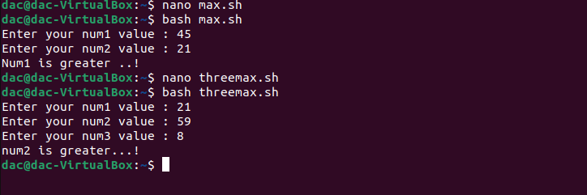

1. Write a Shell Script to check whether a number is negative, positive or zero.

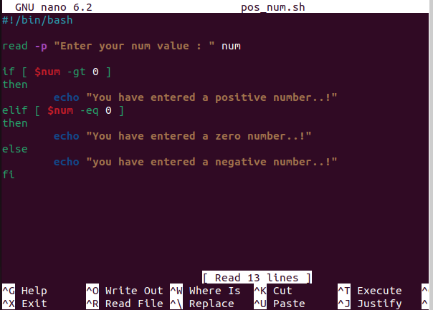

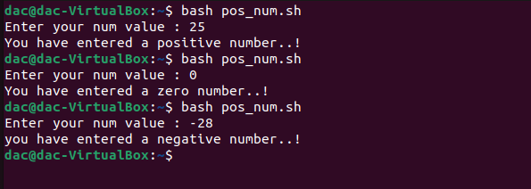

1. Write a Shell Script to check whether a number is divisible by 5 and 11 or not.

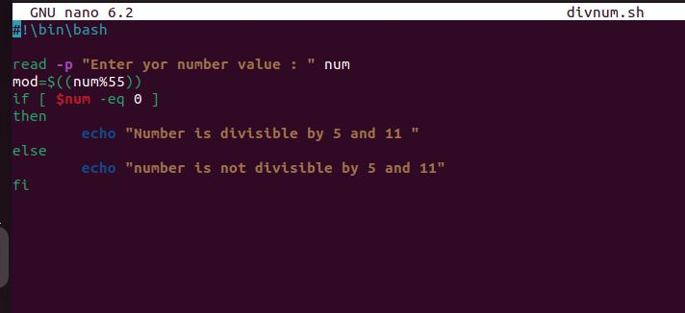

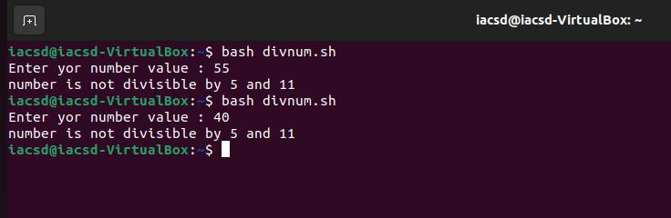

1. Write a Shell Script to check whether a number is even or odd.

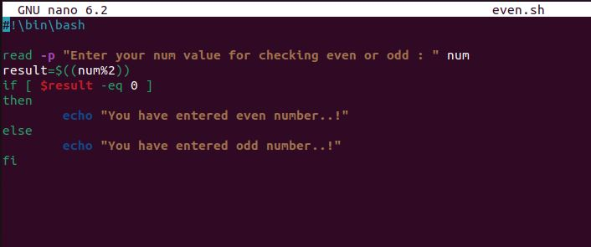

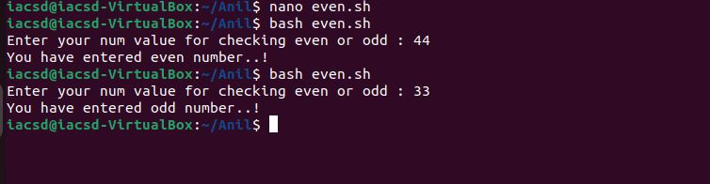

1. Write a Shell Script to check whether a year is leap year or not.

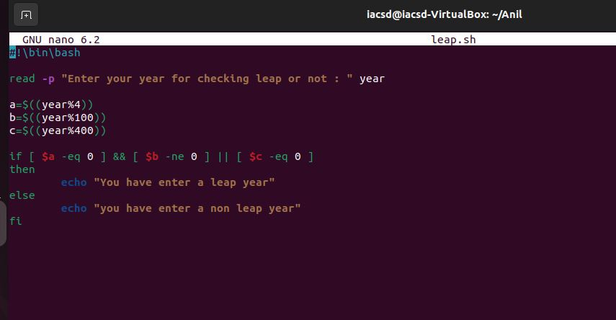

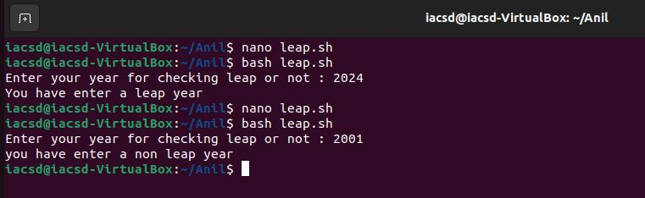

1. Shell Script to print number between 1 to 10 in character format using switch-case.

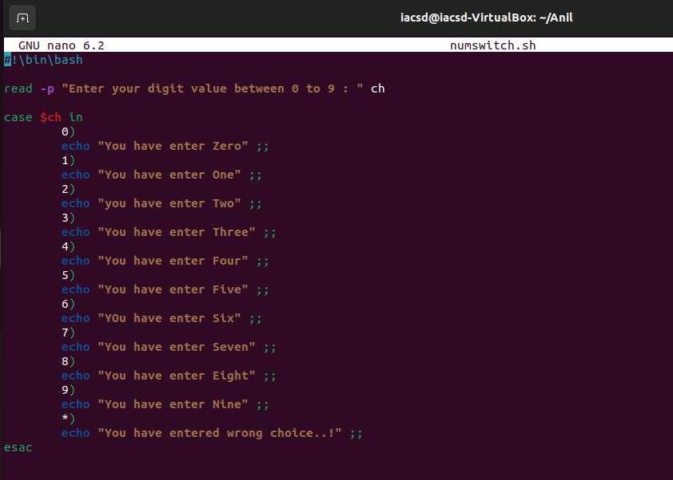

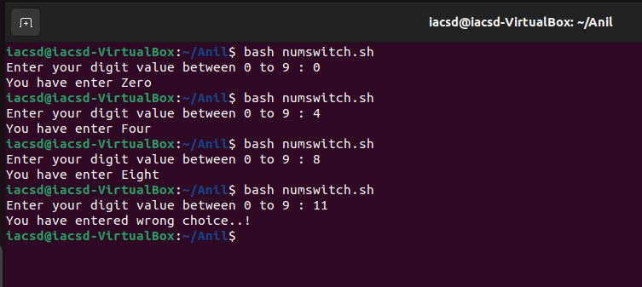

1. Shell Script to accept id from user to confirm department using switch-case.

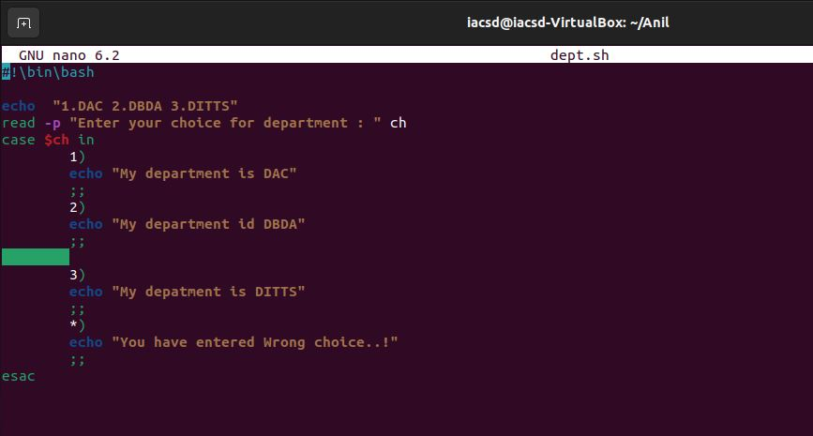

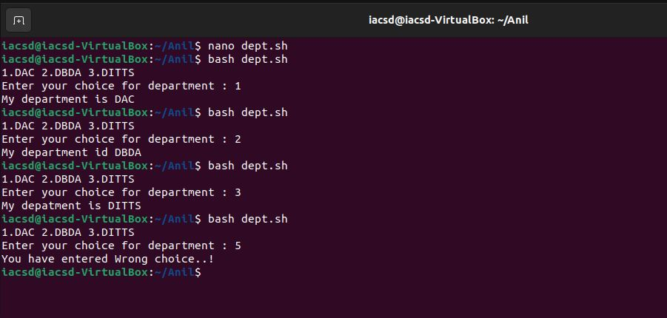

1. Shell Script to check password is correct or incorrect using switch-case.

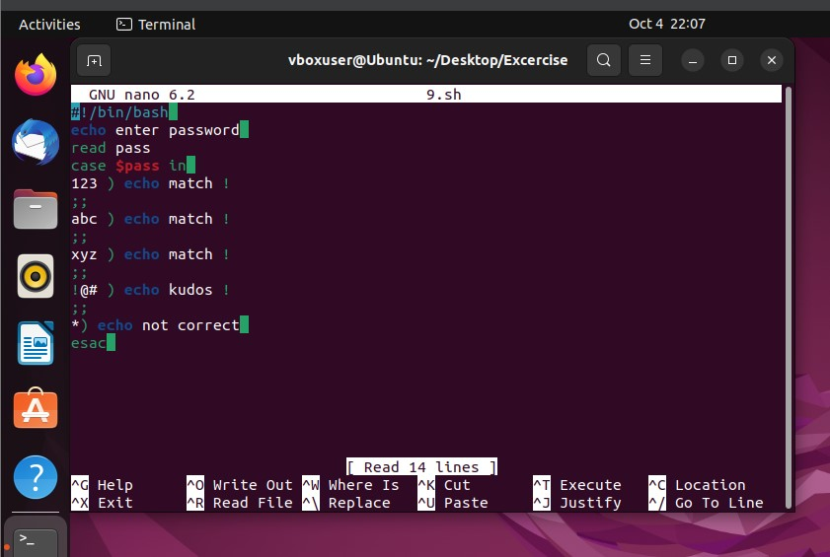

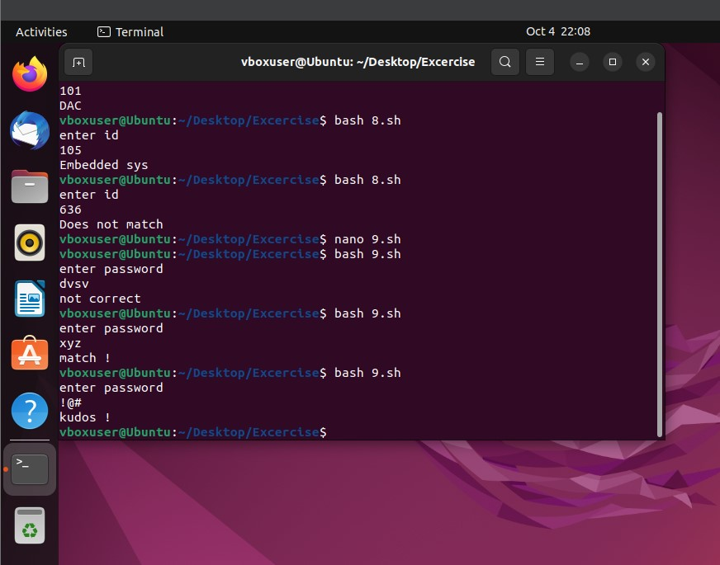

1. Shell Script to print day of week using switch-case.

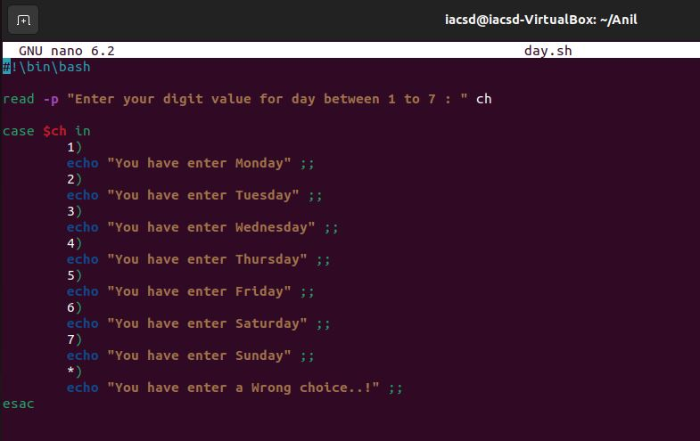

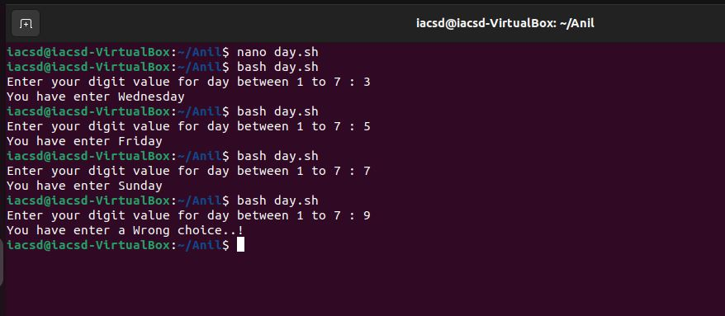

1. Shell Script to create calculator using switch-case.

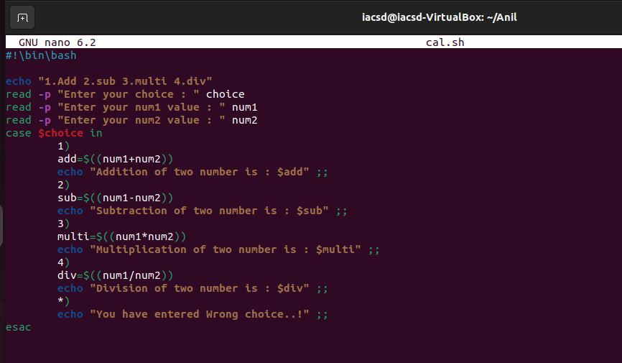

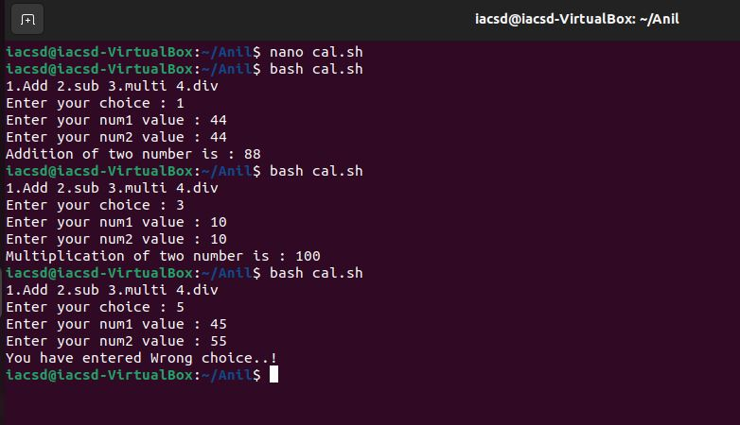

**ASSIGNMENT NO 6**

1. Shell Script to display the first 10 natural numbers.

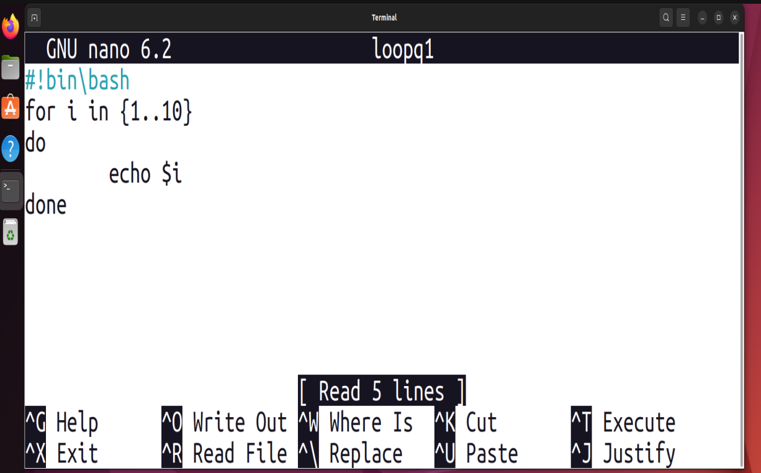

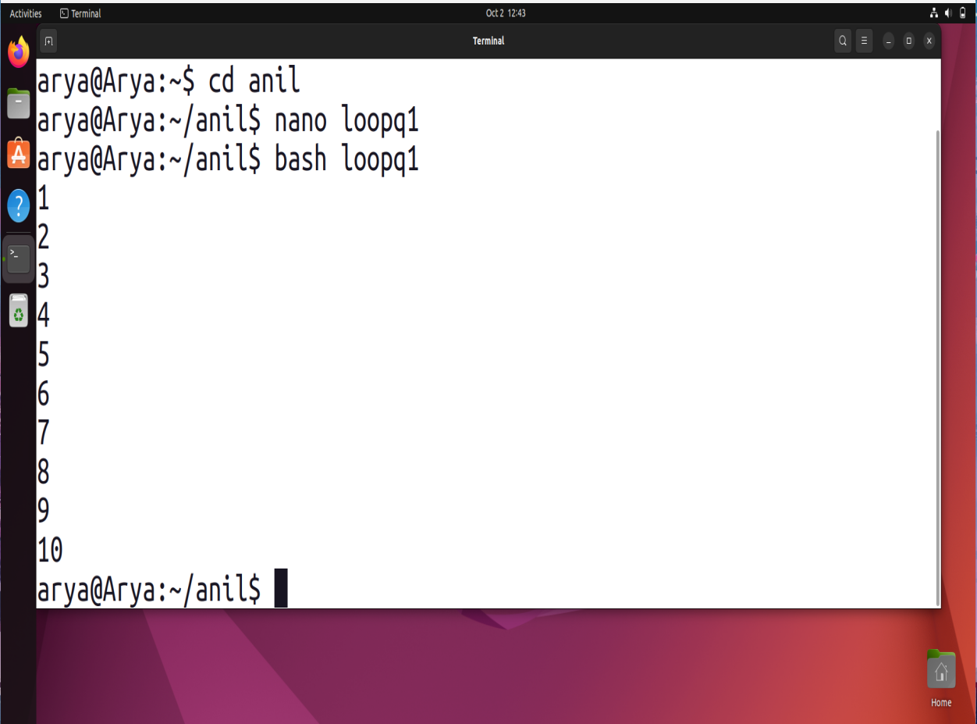

2. Shell Script to compute the sum of the first 10 natural numbers.

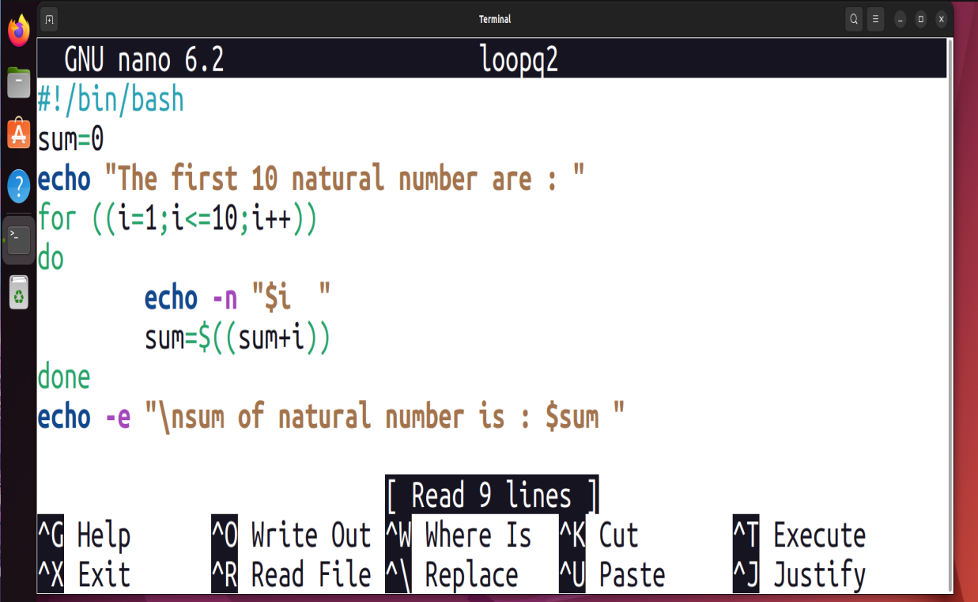

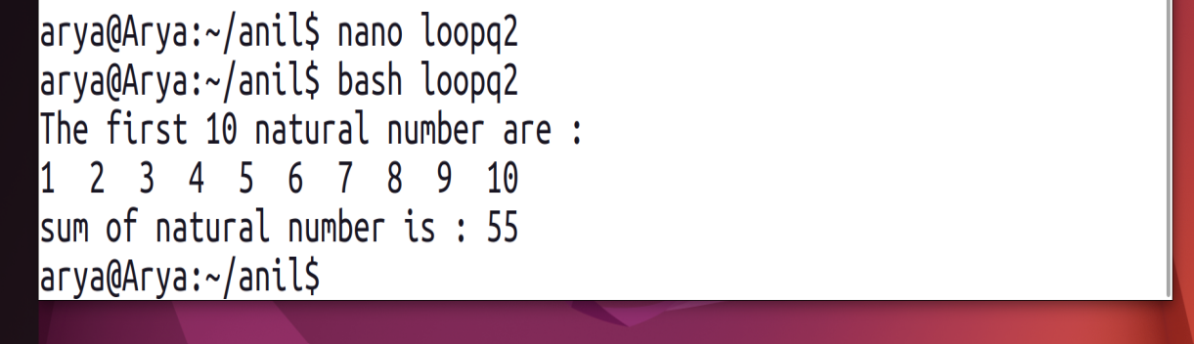

3. Shell Script to display n terms of natural numbers and their sum.

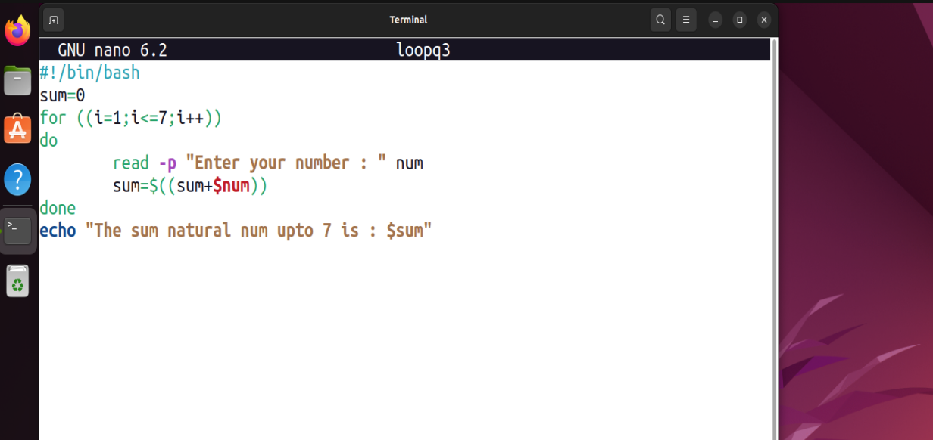

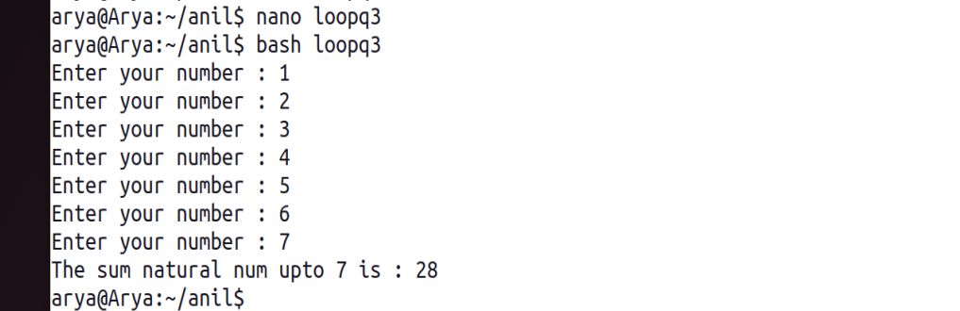

4. Shell Script to read 10 numbers from the keyboard and find their sum and average.

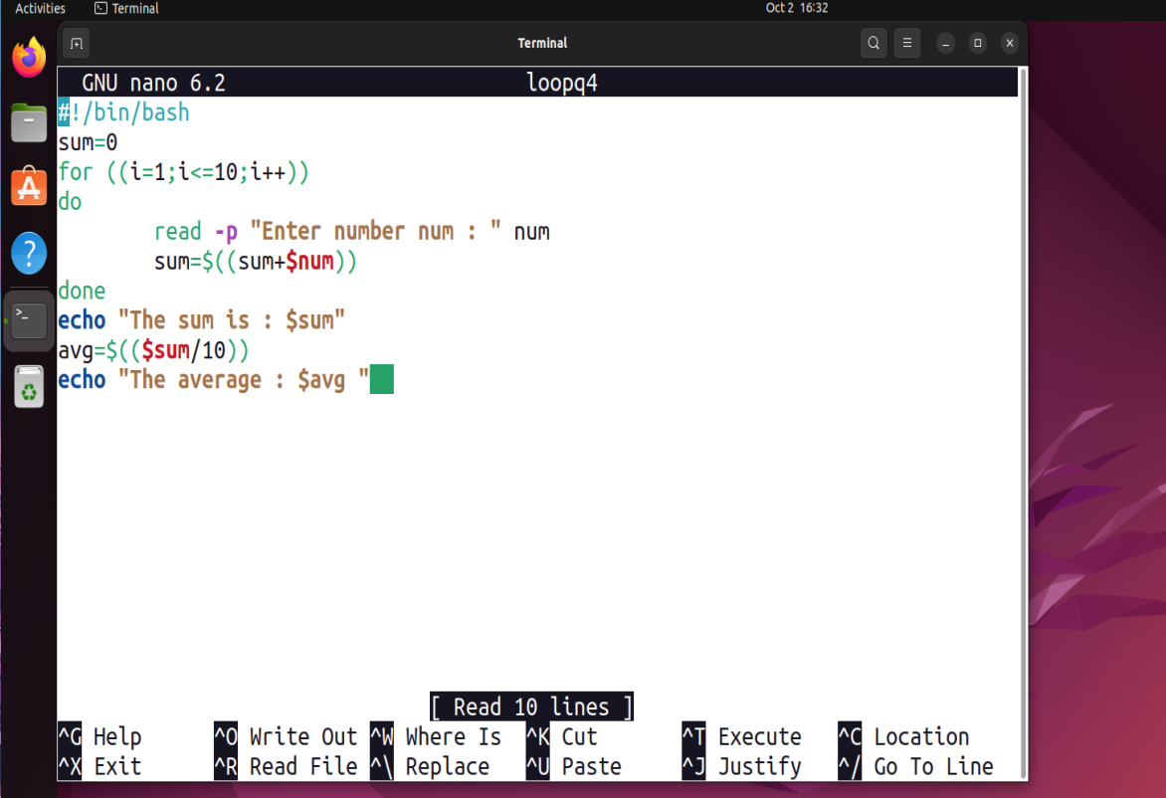

5. Shell Script to display the cube of the number up to an integer.

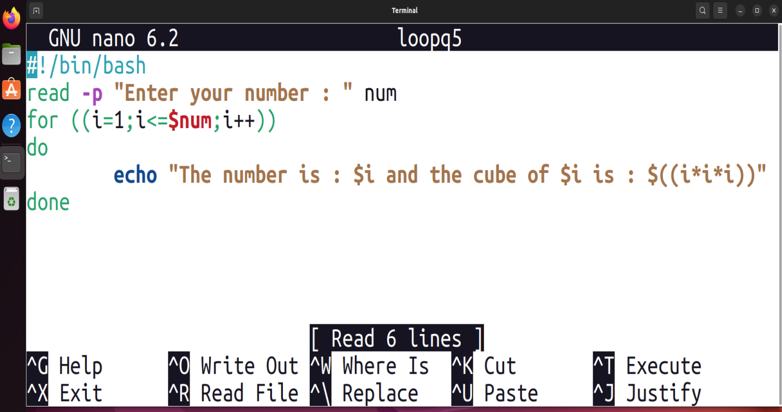

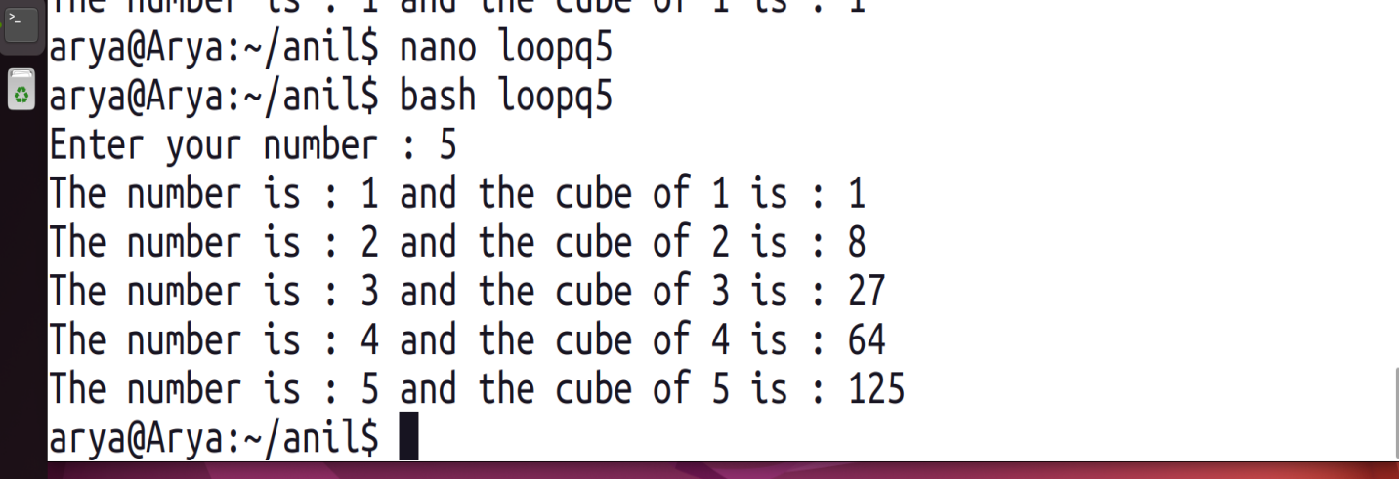

6. Shell Script to display the multiplication table for a given integer.

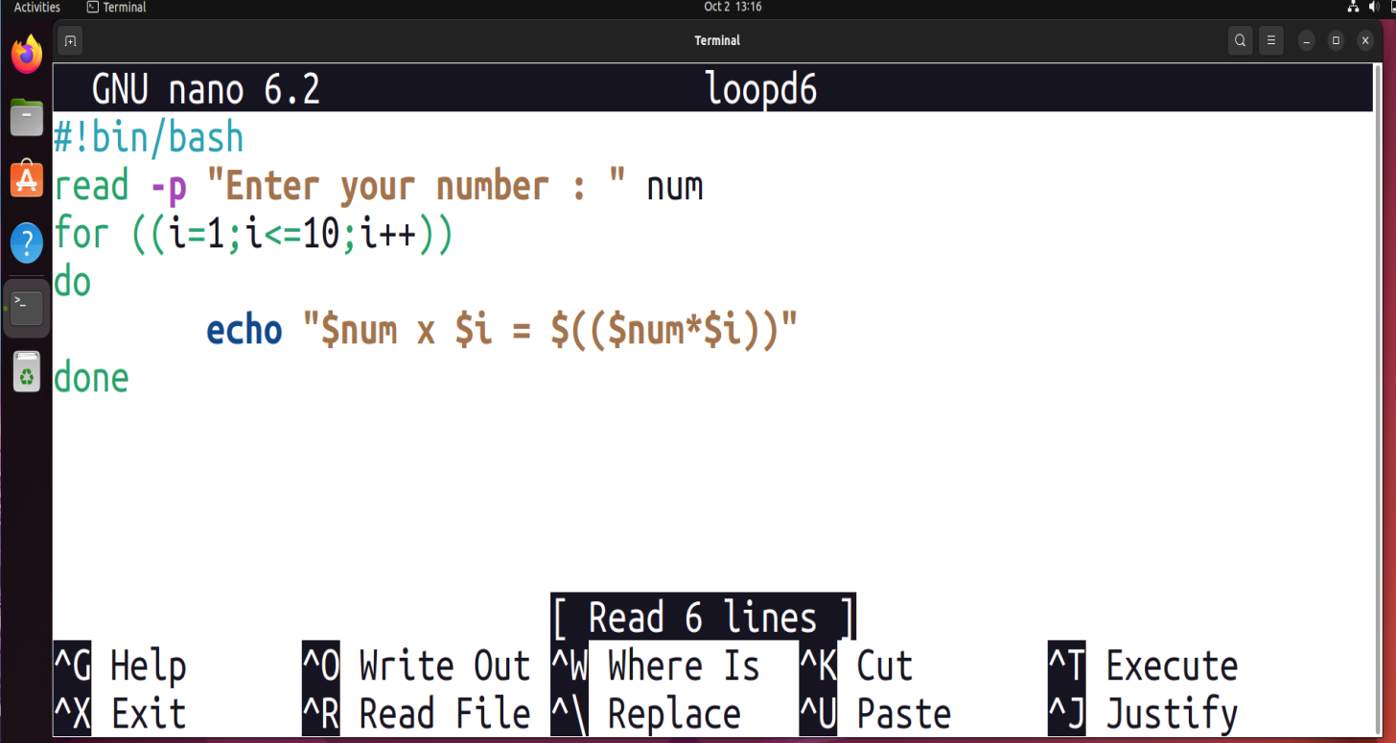

7. Shell Script to display the multiplier table vertically from 1 to n.

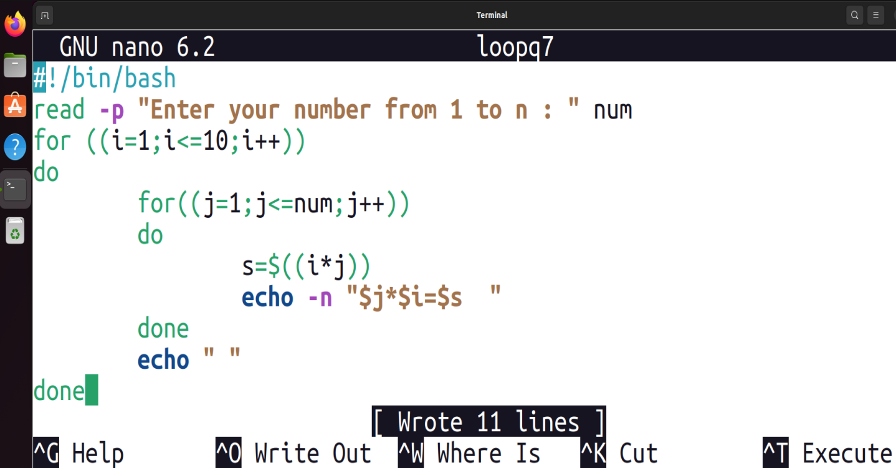

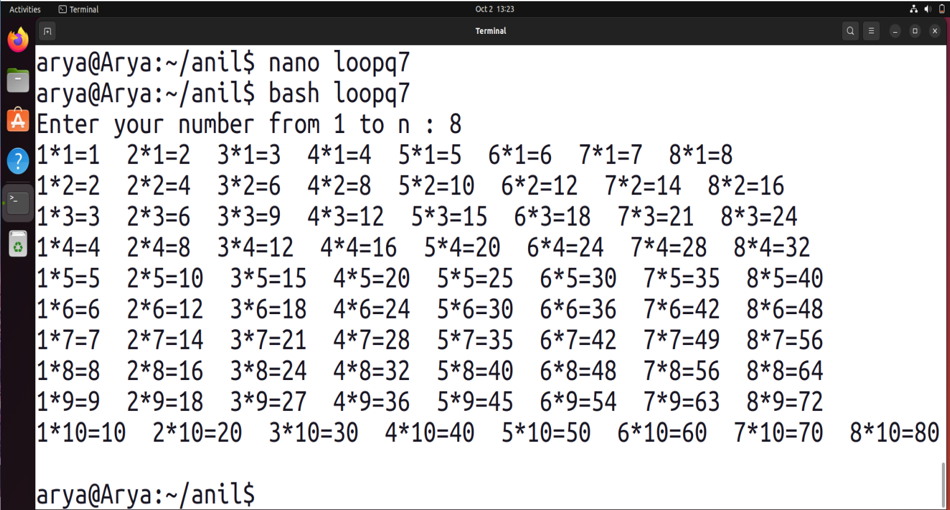

8. Shell Script to display the n terms of odd natural numbers and their sum.

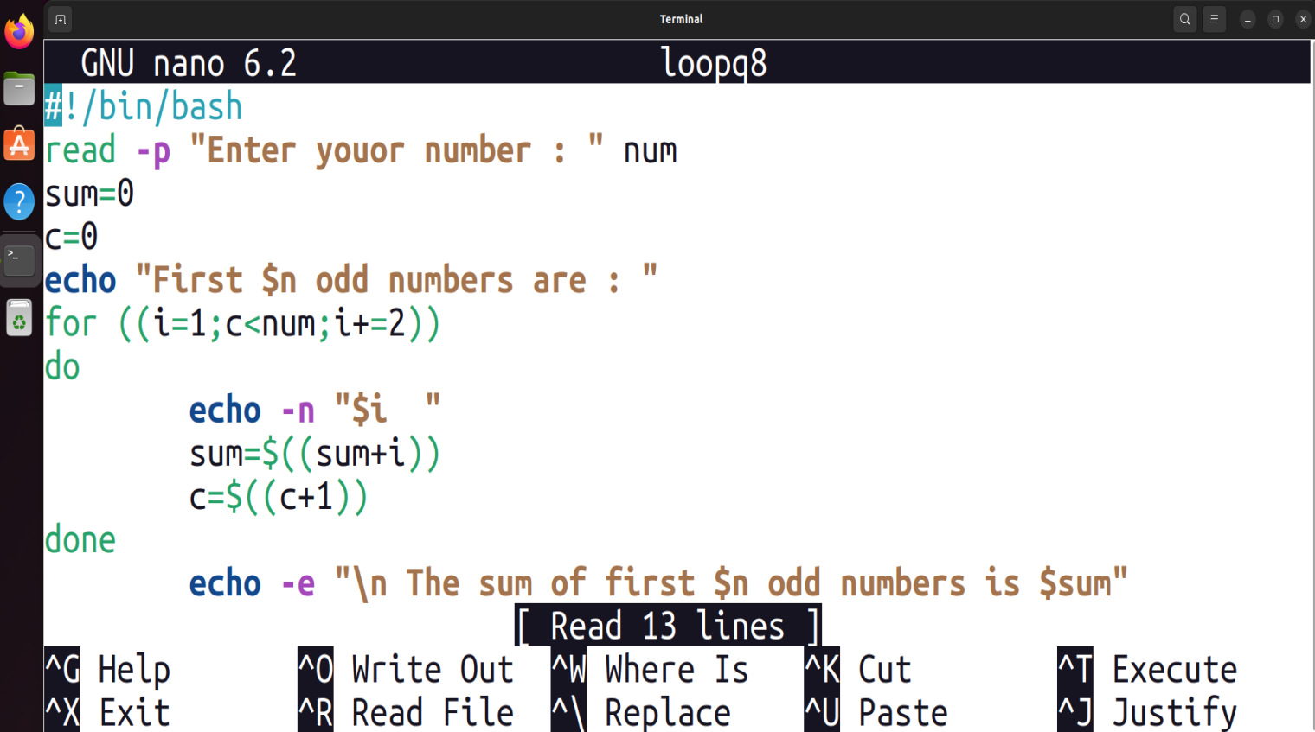

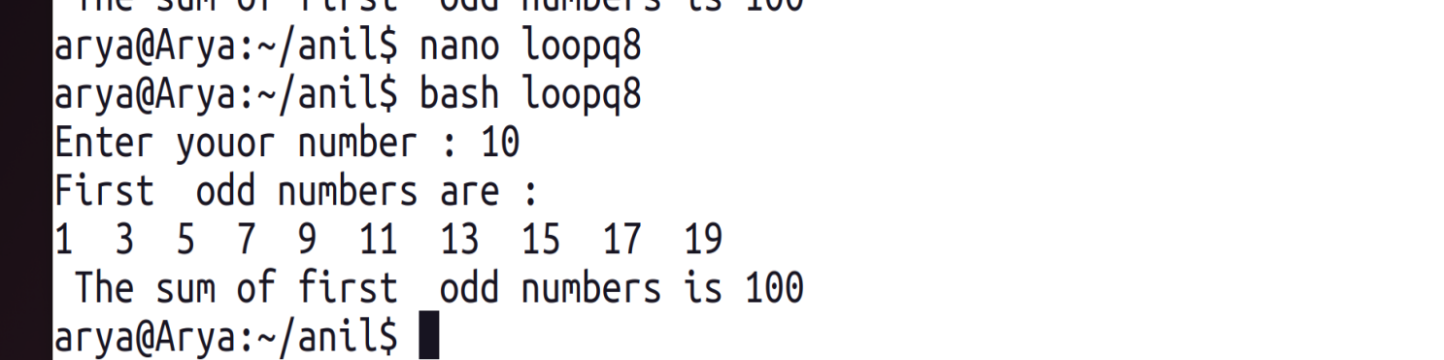

9. Shell Script to display a pattern like a right angle triangle using an asterisk.

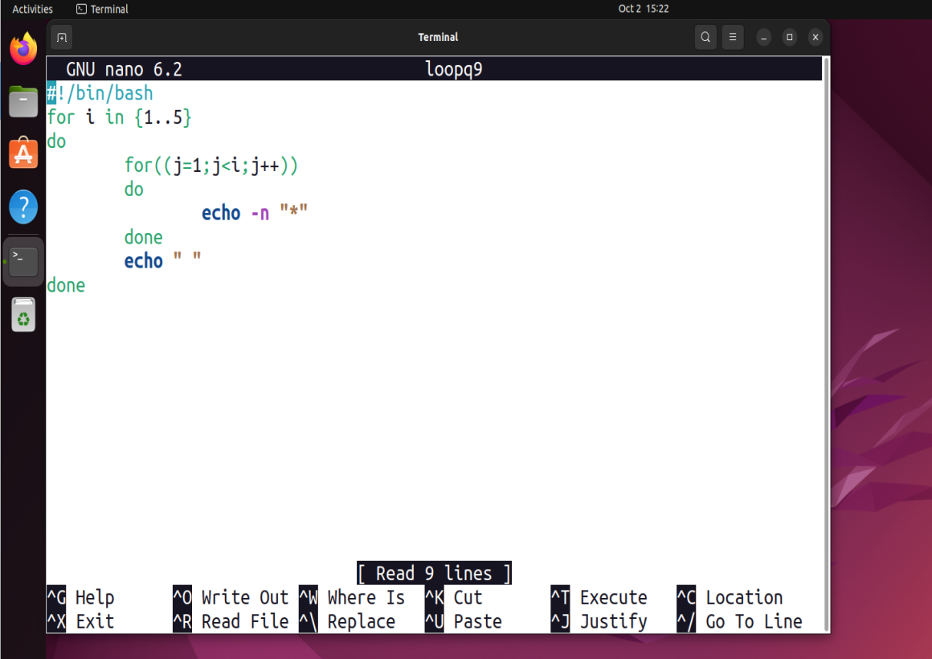

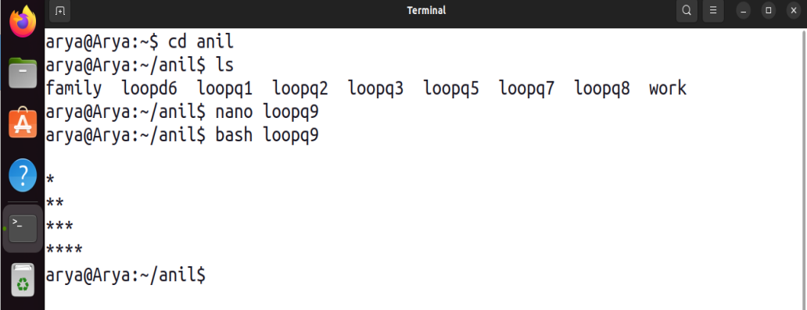

10. Shell Script to display a pattern like a right angle triangle with a number.

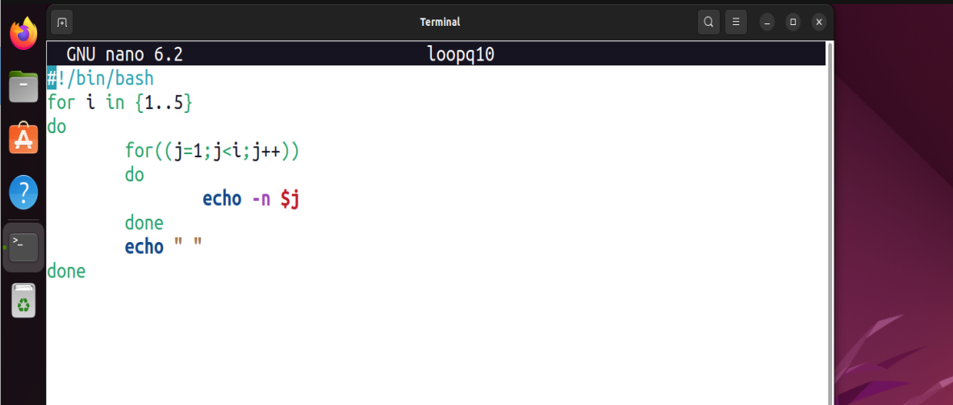

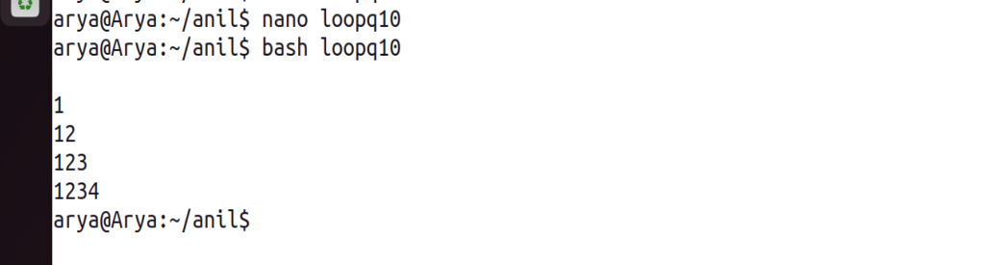

11. Shell Script to make such a pattern like a right angle triangle with a number which will repeat a number in a row.

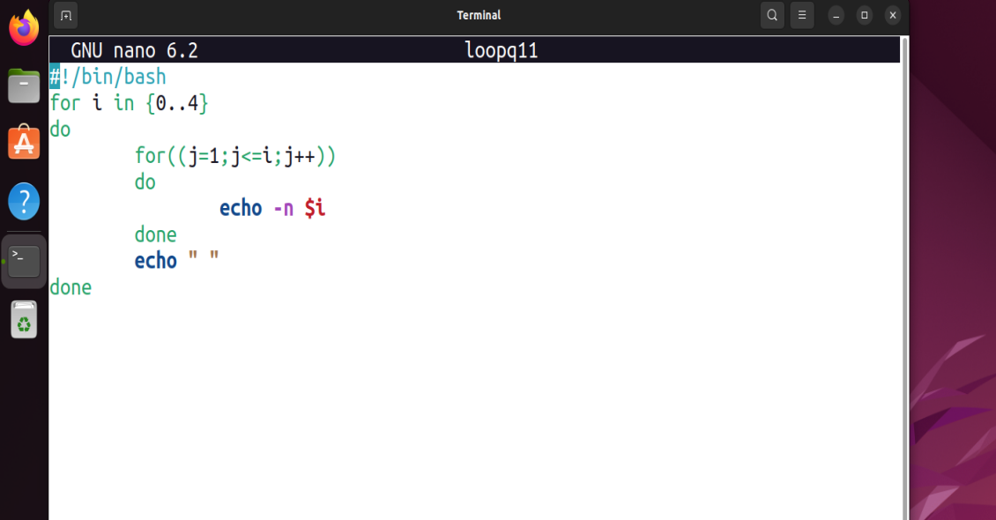

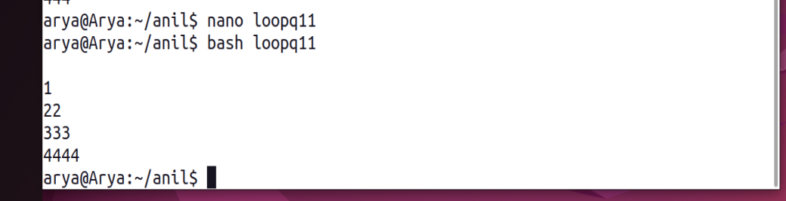

12. Shell Script to make such a pattern like a right angle triangle with the number increased by 1.

